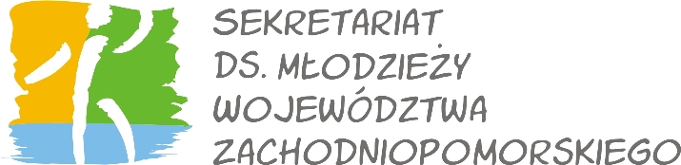
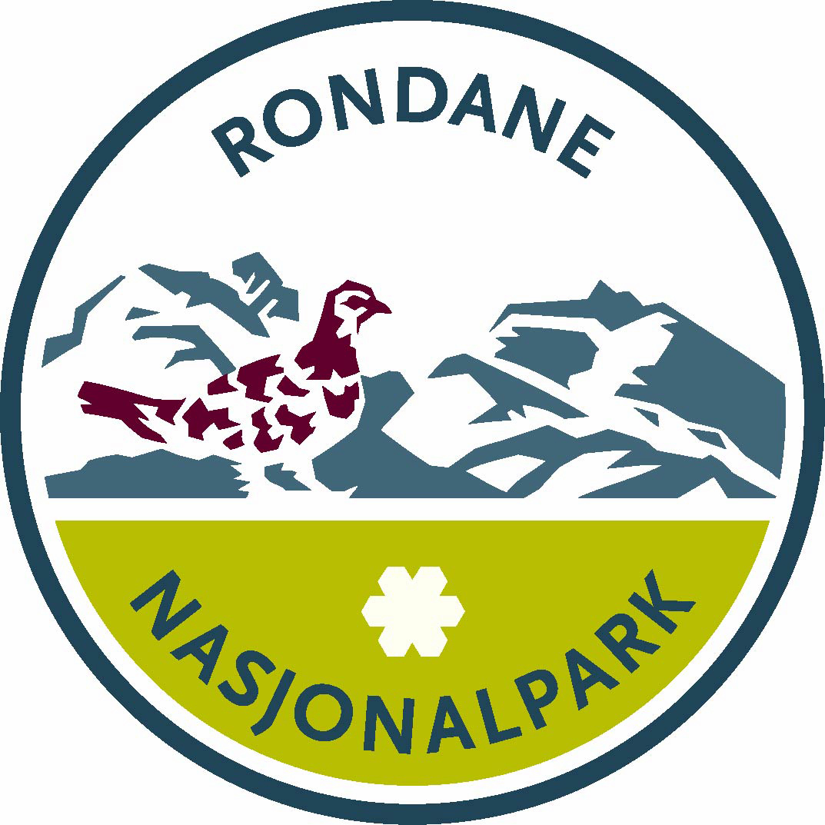

The rediscovery of first Norways National Park
Youth camp at Rondane national park, Norway, 29.07 – 04.08.2012

1. Personal data
Surname: ________________________________ First name: __________________________________
□ Male □ Female
Address: ______________________________________________________________________________
Telephone: ____________________________ Email: ___________________________________
Date of birth: ______________________ Place of birth :________________________________________
Nationality: ________________________
2. English skills (please mark with X):
□ Fluent in speaking and writing □ Communicative

Additional info: certificates, living or working abroad, etc. _______________________________________

3. Motivation
What is your motivation to take part in the international youth camp?

4. Volunteer experience
Do you have previous volunteer experience in nature projects? If, yes please describe in what kind of projects did you took part. When was it?

Are you a member or a volunteer in environmental organization (please mark with X):?
□ YES □ NO

If yes, please describe your organization and its activities?

5. Sport and hike interest
Do you have hiking experience(please mark with X):?
□ YES □ NO

What kind of sports do you like?

Wyrażam zgodę na przetwarzanie moich danych osobowych przez Sekretariat ds. Młodzieży Województwa Zachodniopomorskiego zgodnie z Ustawą z dnia 29 sierpnia 1997 r. o ochronie danych osobowych (Dz. U.2010 r., Nr 229, poz. 1497) w związku z rekrutacją do projektu The rediscovery of first Norways National Park

___________________________________ ______________________________________________
Place, date Signature

Please send this form until 25 May 2012 to cim@cim.info.pl.

